**Project Description**

Payment API Gateway:

* + Credit Card Input Validations - Implemented pre conditions validation
  + Store Credit Card – Insert credit card fields into payment collection
  + Forward Payment to Bank – produces messages by kafka topic *ag.com.payment.gateway-events-v1*
  + Receive Response from Bank - consumes messages by kafka topic *ag.com.bank-events-v1*
  + Forward payment response masked credit card number, card details, status to Merchant – produces messages by kafka topic *ag.com.bank-events-v1.* Which are consumed by payment gateway by topic *ag.com.payment.gateway-events-v1. Masked credit card info using Microsoft Data Protection*
  + Share last payment details – Exposed by endpoint *GetLastPaymentReceived as well as whenever a new payment is created*

Payment Entity:

* + Command – Implemented and persistence mongoDB



* + Query – Implemented and query mongoDB

Shopper Entity :

* + Command – Implemented and persistence mongoDB



* + Query – Implemented and query mongoDB

Merchant Entity

* + Command – Implemented and persistence mongoDB



* + Query – Implemented and query mongoDB

Acquiring Bank

* + Process Payment to 3rd part – Payment gateway produces messages by topic *ag.com.payment.gateway-events-v1* which are consumed by *BankEventHandler* that process the payment
  + Forward transaction ID and status to Payment API – Handlers PaymentEventHandler consumes and BankEventHandler produces messages by topic *ag.com.bank-events-v1 forwarding to payment gateway that insert into mongoDB*
  + Switch to real bank – Just change Kafka server to production

**Extra mile**

* + Application logging – Partially implemented
  + Application metrics - Pending
  + Containerization – **Implemented, run docker compose file in folder deploy. A container with Kafka and Zookeeper is created with all other container. Also a internal network is configured**
  + Authentication – Partially implemented
  + API client - Pending
  + Build script / CI - Pending
  + Performance testing - Partially implemented
  + Encryption - Implemented with Microsoft Data Protection
  + Data storage – **Using MongoDB. Payment gateway connection string is defined for mongo server that is created in Docker container as well as all collections and other objects. No configuration required.**

**Extra extra mile**

* + CQRS Imediator – Developing
  + More unit tests – Pending
  + Add integration tests – Pending

**Testing or debugging**

Swagger: Default address - <http://localhost:5050/swagger/index.html>

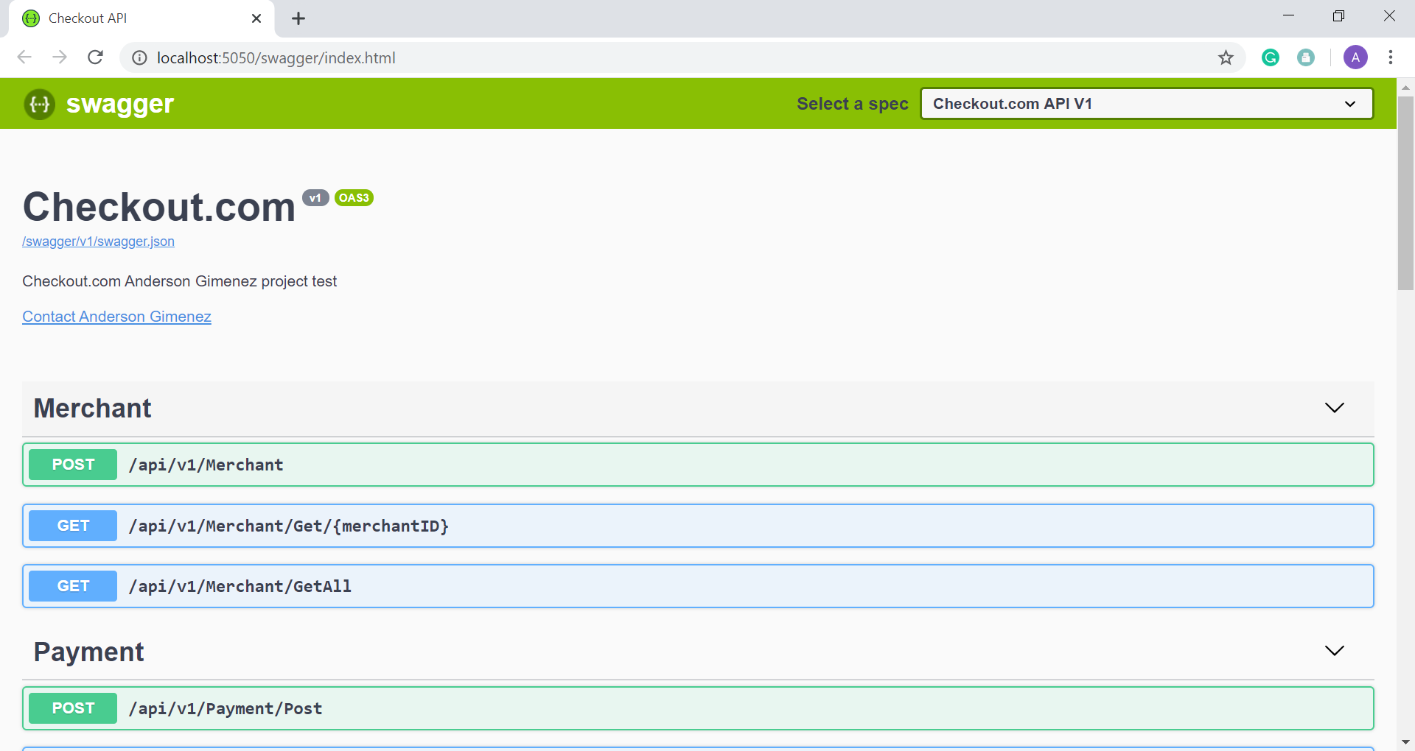

Swagger: Post a payment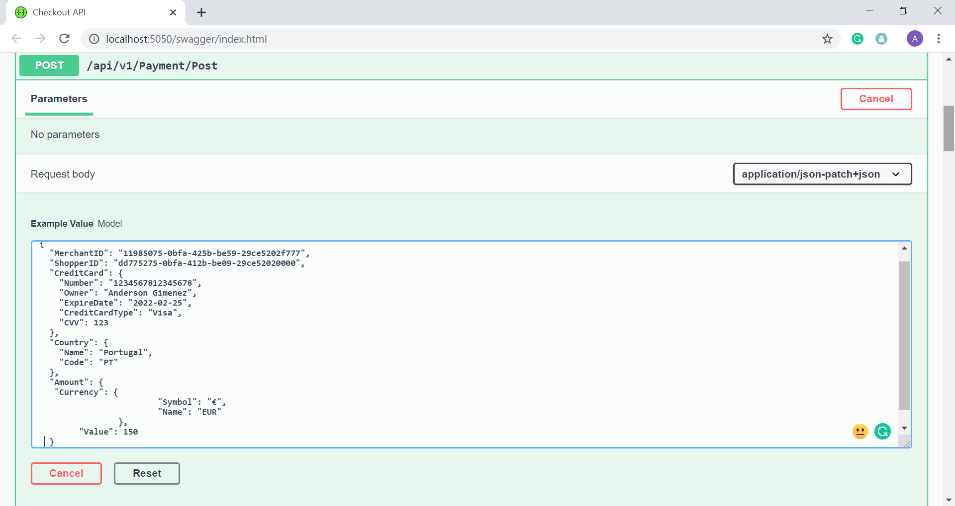

Swagger: Get a payment

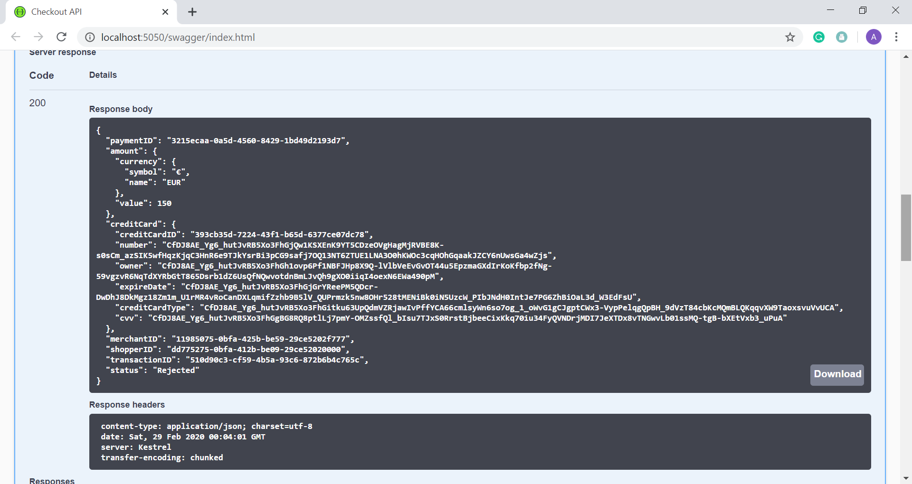

MongoDB: Payment Collection

